Study title | Advanced breast cancer patients treated with oral vinorelbine: a prospective and retrospective, observational study – VINOREAL.
Disease   | advanced breast cancer (ABC).
Treatment(s)  observed   | Any line of treatment using oral vinorelbine (OV).
Participants   | For the retrospective part: Patients who initiated treatment with oral vinorelbine for advanced breast cancer between 2011 and 2020.  For the prospective part: Patients who start oral vinorelbine treatment for advanced breast cancer, at or after being included in the study will be enrolled.
Study dates   | From August 2024 to 2028 (approximate end date).
Study Locations   | Italy, China and Algeria.
We do research to improve patient care. By participating in an observational study, one helps to answer important scientific questions for the benefit of all.

This document is a brief summary of a clinical study protocol. It is written in plain language for the general public, providing answers to the following questions:
- What is the purpose of the study?
- What are the objectives of the study and how are they evaluated?
- How is the study conducted?
- Who can take part in the study?

What is the purpose of the study? | It is not common practice to reappraise drugs that have been available for many years. Oral vinorelbine tartrate is a widely used treatment for ABC, with a very good toxicity profile. There are currently few recent studies supporting the effectiveness of OV in a real-life setting. It would therefore be beneficial to document and reassess the effectiveness and safety profile of OV in monotherapy or in combination with other medications (OV-based treatment) in routine practice.  To achieve this goal, we will be looking at the results from two groups of patients (also called here cohort): those who have already been treated (in the retrospective study part) and those who are currently being treated or will be in the future (in the prospective study part).
What are the objectives of the study and how are they evaluated? | The main (primary) objective is to explain how well a treatment based on OV works by looking at how long patients with ABC can live without their disease getting worse, after two years of being treated. This will be looked at in groups of patients from the past (retrospective part) as well as in groups being treated now and, in the future, (prospective part).  The secondary objectives are:  - To describe how effective a treatment with OV is at helping patients with ABC live longer, measured two years after starting the treatment. This will be looked at in groups of patients from the past (retrospective) and in groups that are currently being treated or will be treated in the future (prospective).  - To describe how effective OV treatment is at helping patients with ABC live without their disease getting worse and at helping them live longer, specifically looking at a group of patients from the past  - To describe the personal details, health conditions, and other illnesses of patients with ABC who are receiving OV treatment, and to see if these details are linked to certain genetic factors. This will be done by looking at patients from both past and ongoing/future groups  - To explain what side effects patients with ABC might experience when treated with OV and how often these side effects happen, in both past and ongoing/future patient groups  - To look at the actual treatment approaches for patients with ABC who are receiving OV, including what treatments they had before, the amount and length of OV treatment, any breaks or stops in treatment and why, and any other treatments they are taking at the same time, in both past and ongoing/future patient groups.  - To look at how patients with ABC treated with OV, access healthcare and their treatment journey, including hospital stays, radiation therapy, and surgeries, in both past and future patient groups.  - To evaluate how the quality-of-life changes over time for patients with ABC who are currently receiving OV treatment by using a survey (that is to say the Functional Assessment of Cancer Therapy questionnaire) that measures the health status of breast cancer patients.  - To find out what current patients with ABC being treated with OV prefer in terms of how they receive their OV treatment by asking them to fill out a survey about their preferences.  - To study how cancer affects the work and daily life of current patients with ABC who are treated with OV by using a survey that asks about work and activity levels
How is the study conducted? | The following diagram summarizes how the study is designed
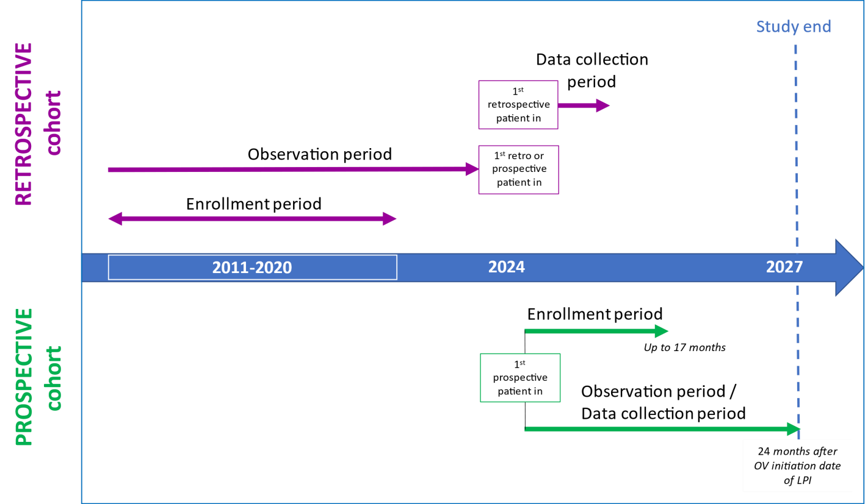
The enrollment period is the period during which patients will be selected based on the study's inclusion criteria.
- for the retrospective cohort: patients included based on past records and who started OV treatment for ABC at any time from 2011 to 2020 in this group. We will look back on their data, after two (2) years of recorded treatment.
- for the prospective cohort: upcoming patients to be enrolled are patients who begin OV treatment when they join the study or after, and who can provide information over time about their quality of life and fill out surveys about their treatment preferences and how their illness affects their work and daily activities. They will be included in this group and will be tracked moving forward.

Who can take part in the study? | People can join the study if they meet all these requirements:  - Women of 18 years or older (19 and older in Algeria) when they start taking the oral vinorelbine treatment  - Women diagnosed with an advanced form of breast cancer that can be treated with chemotherapy  - women who started treatment with oral vinorelbine for advanced breast cancer between January 2011 and December 2020 for the past group and women who start or will be starting this treatment when they join the study for the prospective group.  - Women who are willing and able to fill out surveys about their quality of life, their treatment preferences, and how their illness affects their work and daily life for the prospective group.  - Women who have given their permission, or if they can't, their family or legal representative has agreed to let their health information be collected and looked at, following what is allowed in their home country.

Clinical Study identification
Protocol Number  Protocol Version | NIS16760  Version 2.0 dated 24 May 2024
Full study title | Advanced breast cancer patients treated with oral vinorelbine: a prospective and retrospective, observational study - VINOREAL.
Registry ID | NCT06500494
Who sponsors this study?
Name and contact details of the sponsor | Pierre Fabre Médicament  Les Cauquillous  81500 Lavaur-France
Additional Information

 | none

Glossary
First line treatment | Initial, preferred or best treatment given after diagnosis of a disease.
Informed Consent Form | A document in which patients are given important information in easy-to-understand language, including possible risks and benefits, about a medical procedure or treatment, genetic testing, or a clinical trial. This is to help them decide if they want to be treated, tested, or take part in the trial. Patients are also given any new information that might affect their decision to continue.
Prospective enrollment | Enrollment in the study conducted at or before treatment initiation.
Retrospective enrollment | Enrollment in the study conducted after treatment initiation.
any line treatment | therapy that can be given at any stage in the sequence of treatments for a disease.

