Trial title | A trial to demonstrate that administration of binimetinib treatment using a 45 mg strength tablet is equivalent to 3 tablets of 15 mg.
Disease   | Healthy volunteers
Treatment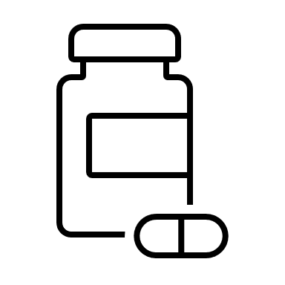 | Binimetinib (MEKTOVI®)
Participants   | Healthy volunteers aged between 18 and 65 years except pregnant women and women of childbearing potential
Trial dates   | From 31 August 2022 (First participant first visit) to 18 January 2023 (End of trial)
Trial Locations   | Biotrial center, Rennes - France
We do research to improve patient care. This trial helped us to ease cancer therapy for patients treated with binimetinib

This document is a summary of trial results and conclusions written for the general public and people who took part in the trial.
This summary was finalized in August 2024. The information in this summary does not include additional information available after this date.

To people who took part in the trial, Pierre Fabre Pharmaceutical group would like to say
THANK YOU
We hope this document helps you understand and feel proud of your key role in medical research. If you have questions about the results, please speak with the doctor or staff at your study site.
To learn about the trial and its conduct:
- What was the purpose of the trial?
- What were the objectives and how were they evaluated?
- How was the trial conducted?
To get a summary of trial results:
- What were the results of the trial?

THE TRIAL
What was the purpose of the trial? | Binimitenib (MEKTOVI®) is a marketed drug for the treatment of adults' patients with unresectable or metastatic melanoma presenting a specific mutation (BRAF V600 mutation).  In order to facilitate treatment administration, a new strength tablet containing 45 mg of binimetinib was developed. As a result, the number of binimetinib tablets to be taken by the patients is reduced from 6 tablets (6 x 15 mg) to 2 tablets (2 x 45 mg) per day.  The purpose of the trial was to demonstrate the bioequivalence of the two formulations; it means that binimetinib treatment is delivered to the body in the same way (quantity and speed) with a 45 mg-tablet as with 3 tablets of 15 mg.
What were the objectives and how were they evaluated? | The primary objective of the trial was to compare the concentration of binimetinib in the blood after administration of both formulations.  Measure of concentration at different time points following administration provided estimation for:  • the total exposure to binimetinib experienced by the participant. The total exposure was the amount of treatment circulating in the blood from administration to elimination.  • the maximal concentration observed in the blood  These were primary pharmacokinetic parameters used to assess bioequivalence.  In addition, the trial allowed:  • To compare additional pharmacokinetic parameters such as the time between treatment administration and observation of the maximal concentration in the blood  • To evaluate the safety of both formulations of binimetinib according to the number and type of side effects
How was the trial conducted? | This was a randomized, crossover Phase I trial.  Randomized means that healthy volunteers were split in two groups using an element of chance:  • one group received the reference formulation first (3 tablets of 15 mg) then the test formulation (one tablet of 45 mg)  • one group received the test formulation first then the reference formulation.  Crossover means that each healthy volunteer sequentially received both formulations.  The trial consisted of:  • A screening period before the first treatment administration to check that participant fulfilled all conditions to enter the trial  • A first treatment period of 5 days, requiring overnight stay at trial center for the first 3 days following the first administration.  • A washout period of at least 7 days required for the body to eliminate drug from first administration.  • A second treatment period of 5 days, requiring overnight stay at trial center for the first 3 days following the second administration.  • An End-of-Study visit performed 1 month after last administration for a final examination of the participant.  The trial was carried out in a center specialized in phase 1 trials with experienced medical staff and adequate facilities.

THE RESULTS
This is a summary of the main results and conclusions of the trial. Please note that:
- These are the results from all the participants combined. The individual results of each participant might be different and are not in this summary.
- This summary reflects the outcome of one single trial and that other trials may show other results or other outcomes.
Participants

This trial was done in healthy people who volunteered to participate.
A total of 37 adult healthy volunteers took part in the trial. This included 33 men and 4 women. The youngest participant was 19 years old and the oldest was 65 years old.
This trial was done in France. Of the 37 participants who entered the trial, all participants completed the trial.
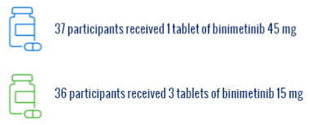

Pharmacokinetic Results
This trial showed that the concentration of binimetinib in the blood was about the same if taken as 1 tablet of 45 mg or as three tablets of 15 mg.
Side effects
Like all medicines, binimetinib can cause side effects although not everybody gets them. The researchers recorded any side effects the participants had during the trial.
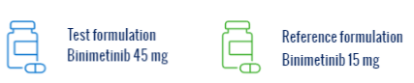
- 4 out of 37 participants (10.8%) who took 1 tablet of binimetinib 45 mg reported at least 1 side effect. These side effects were: COVID-19 infection, awareness of the eyes, retinal vascular disorder, stomach pain and low blood pressure related to the upright position.
Researchers believe that only the side effect low blood pressure was related to the treatment binimetinib.
- 5 out of 36 participants (13.9%) who took 3 tablets of binimetinib 15 mg reported at least 1 side effect. These side effects were: COVID-19 infection, a pus-filled swelling in the tooth, viral infection, vision blurred, anal itchiness, frequent defecation and pain in a tooth.
Researchers believe that only the side effect vision blurred was related to the treatment binimetinib.
No participants had a serious side effect during the trial or stopped the treatment due to a side effect.

For more information on the results, see the Additional information section on the next page.

Clinical Trial identification
Protocol Number | W00074CI103
Protocol | 1.2 dated 22 June 2022
Full trial title | A randomized, single-center, open-label, single dose, two-period, crossover pivotal bioequivalence study comparing binimetinib 3 x 15 mg and 45 mg tablets in healthy participants
Registry ID | EudraCT Number: 2022-000610-34  ClinicalTrials.gov: NCT05810740  W00074CI103 - ClinicalTrials.gov
Who sponsors this trial?
Name and contact details of the sponsor | Pierre Fabre Médicament  Les Cauquillous  81500 Lavaur-France
Additional information
This summary of the clinical trial results is available online at Pierre Fabre's Clinical Trials Website.
For more information:
- on this clinical trial, please visit: Pierre Fabre's Clinical Trials Website
- on the summary of the trial’s protocol, please visit W00074CI103 Clinical Trial Protocol Lay Synopsis
- on the results of the trial, please visit W00074CI103 - ClinicalTrials.gov

Glossary
BRAF^{V600E} | All humans have a gene called BRAF. The BRAF gene makes a protein that helps control cell growth. In some patients with colorectal cancer, this gene mutates (V600E mutation) and makes the tumor grow faster.
Crossover trials | Crossover trials are trials in which participants do not only receive one intervention, but multiple, and the effect of the interventions are measured on the same individuals.
Healthy volunteers | Healthy volunteers in phase 1 clinical trials contribute to the development of safe drugs and accept risks and constraints without anticipated health benefits from participation.
Metastatic | Metastatic means that cancer has spread to a different part of the body than where it started.
Pharmacokinetic | The pharmacokinetic of a drug is how the body absorbs, transforms, and eliminates this drug.
Phase I trials | Phase I trials test an experimental drug, in a small group of people to evaluate safety, identify side effects and determine safe dosages.
Randomization | Randomization is the assignment to one of the treatment groups using an element of chance.
 | A condition that affects the blood vessels of the eye.
A side effect is serious when:
- The patient needs to be hospitalized.
- The patient’s life is in danger.
It causes permanent damage or death.
Side effects | Side effects are unwanted medical events (such as headache) that happen during the trial and that are related or possibly related to trial treatment.
Unresectable | that cannot be removed by surgery.

